**Name :- Rushikesh Anil Mashidkar**

**Email Id :-** [**rishikeshmashidkar@gmail.com**](mailto:rishikeshmashidkar@gmail.com)

**Note :- The answer is in bullets ( 🡺 )**

**Basic Linux Commands Assignments : Day 2**

**Assignment-1**

Connect and disconnect with login Access

* What happens when you login a non-existent users or username?
  + Provide Screenshot and What you understand, explain in short brief?
* We cannot login with non-existent users or username.

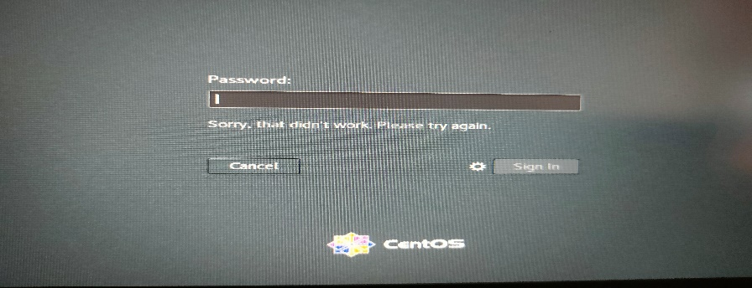

* We have to create or assign users or username to the machine then we have to access the machine with that username & password. We didn’t access the virtual machine without existent user .

**Assignment-2**

Password changing

* + Login into your account and then change password?
* Change your password into IneuR0n#42 and hit the Enter key
* Explain what happen and give screenshot?
* First I run a command name **passwd** then it says to add current UNIX password so I enter my password then it says to type a new password so I enter the new password that is **IneuR0n#42** and again I enter this password and it change perfectly. 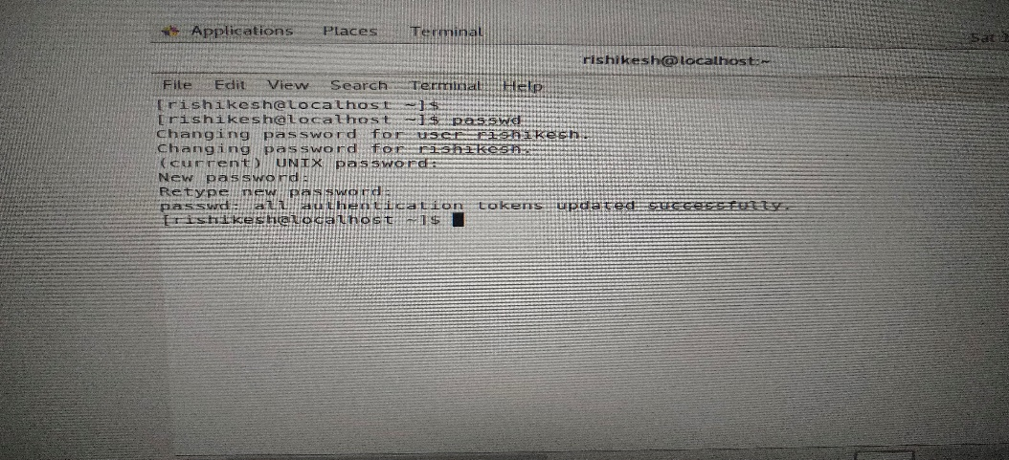

o Try again to change password but use like password 1234 or abcd

* I change password to IneuR0n#42 after that im trying to change password to abcd or 1234 it shows that it was a bad password and password must be 8 character or the above.

▪ Explain what happen and give screenshot?

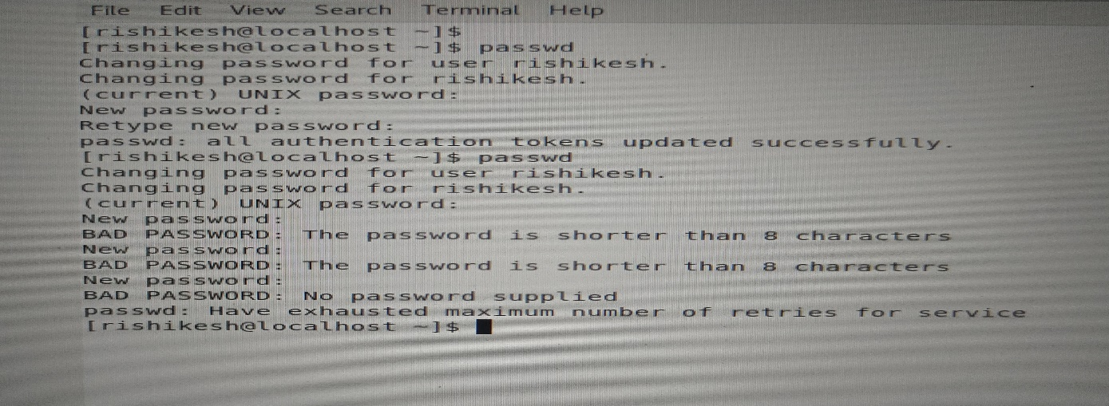

o Try again to change password but now don’t use any password just hit Enter key

▪ Explain what happen and give screenshot?

* When im trying to change password to nothing means nothing just hit the enter . it again said that bad password and machine cannot find any password. And one more thing that I back to back hit all this bad password then it says you have maximum number of retries for changing the password.

**Assignment-3**

Working with Directories

• Enter the command cd / and then ls and then hit Enter key

o Take screenshot and explain what output we got?

• Enter the command now cd /home and then hit Enter key

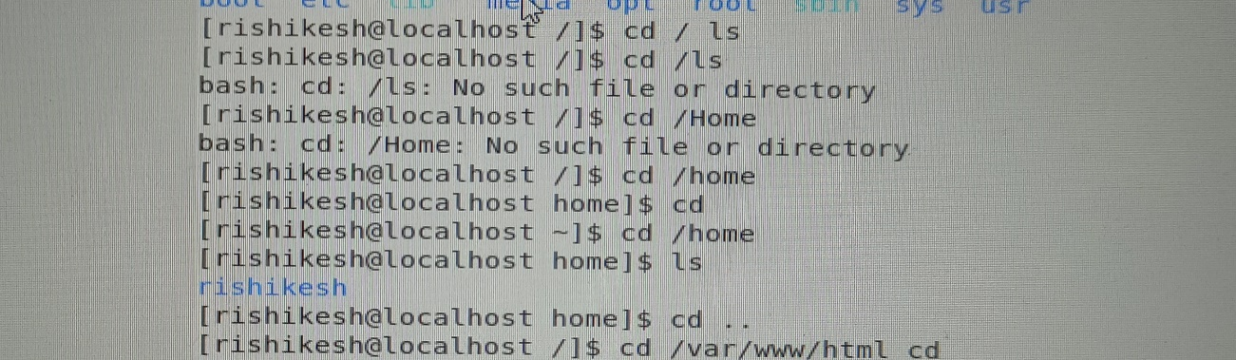

* When we enter **cd / and then ls** i.e **cd /ls** here are showing that there are no such file or directory named **ls .**
* When take cd /home it will take in home directory where all folder & files are available to see.

o Do ls, provide screenshot and explain what is /home directory used for?

* Home directory is all containing files for the user of user.

• Enter cd .. and hit Enter key [ Note: here we have space after cd then use double dot]

o Check what happen and give screenshot?

* Its take you to back . To go the back/previous use command “cd ..” .

• Now enter cd /var/www/html and then type cd and hit Enter key

o Explain what happen and give screenshot?

* No such file or directory available in system under the name containing /var/www/html or any one of these.

• Now type cd /root and then hit Enter key

o Do ls, check any output we have on screen if yes then take screenshot?

* When type cd /root it denied the permission of it.

**Assignment-4**

Working with File Listing

• Go to cd /etc and type ls

o Take screenshot and explain what files you have seeing?

o Take screenshot and explain what different output you found compare to previous

command you used?

* No files are here but it takes in etc directory or file.

• Then type ls -al and hit Enter key

o Take screenshot and explain what new file or directory you found?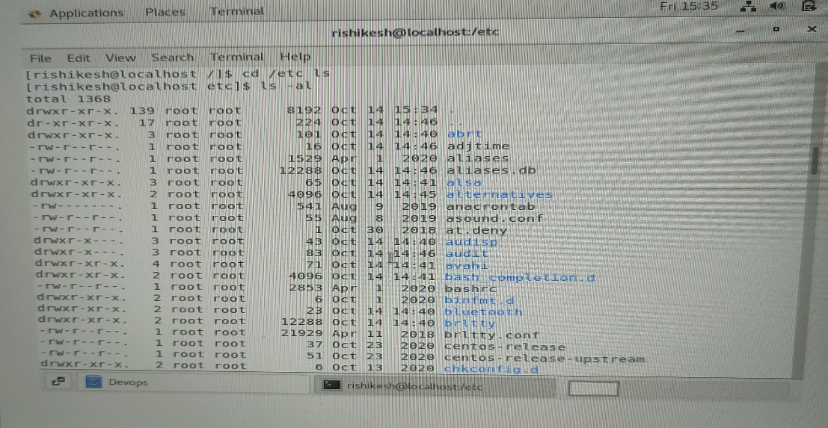

* There are total 1368 files are visible with containing their permission, date and something more.

• Then use ls -i and hit Enter key

o Now see what different output its shows and take screenshot?

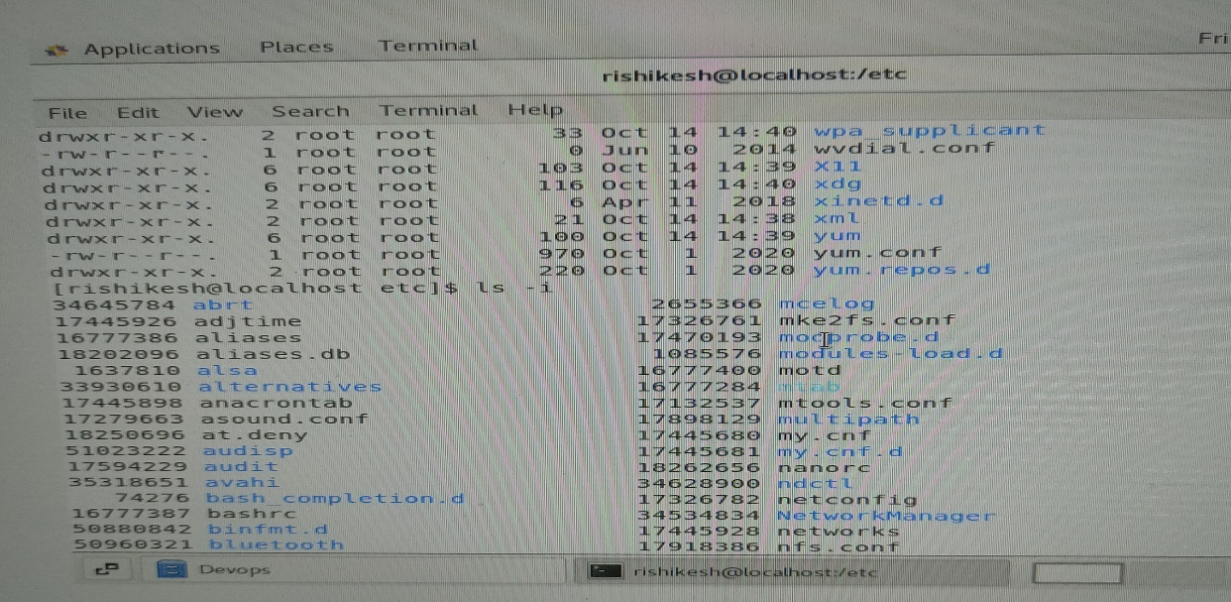

* May be same files as the above but here only the files names with some number I don’t know what it is. Yeah I got it from the command “ls --help” . it shows the index number .

• Then use ls –help and see other options about ls command

* When we take ls -help it shows invalid option here and suggested to do in correct syntex that is “ls --help” for information.

o Explore it and try with other attribute we can use with ls command

**Assignment-5**

Know where you are and where you working

Here we use pwd, cd and ls as combine task to understand where you working on terminal and how

you can switch from one directory to another one.

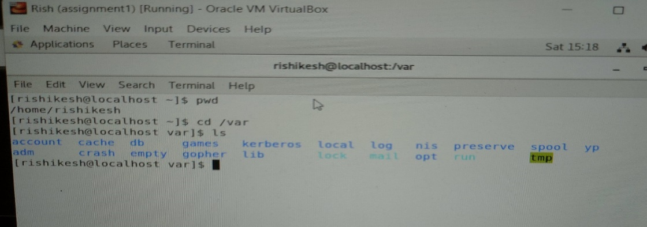

• Open terminal after restart the linux

o Check which location you working, type pwd and take screenshot

* It shows /home/Rishikesh directory.

• Now use cd /var and hit Enter key

* Its jump on the /var directory.

o Do ls, and see what output comes, give screenshot?

* Its shows the list of all files in /var directory.

• Do explore other help options of each command to learn more other things we can do with

these commands

* **Assignment-6** & **Assignment**-**7** that is the update and full screen I have done but don’t know how to see that update .